6.An online food delivery platform enables customers to browse restaurants, view menus, place food orders, make online payments, and track delivery status. Restaurants use the system to manage their menus and update order status, while delivery agents are responsible for accepting delivery requests and updating delivery progress. Design a Class Diagram, Use case Diagram and Activity Diagram for the Online Food Delivery System showing the relevant classes, their attributes, methods, and relationships.

Aim
To design a Class Diagram for the Online Food Delivery System using Umbrello UML Modeller, showing the classes, attributes, methods, and relationships among them.

Procedure
- Open Umbrello UML Modeller.
- Create a new UML project.
- Select Class Diagram.
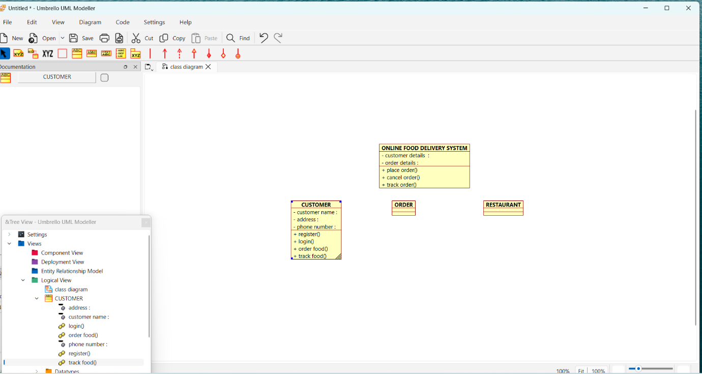
- Create the classes: Customer, Order, Restaurant.
- Add the required attributes and methods to each class.
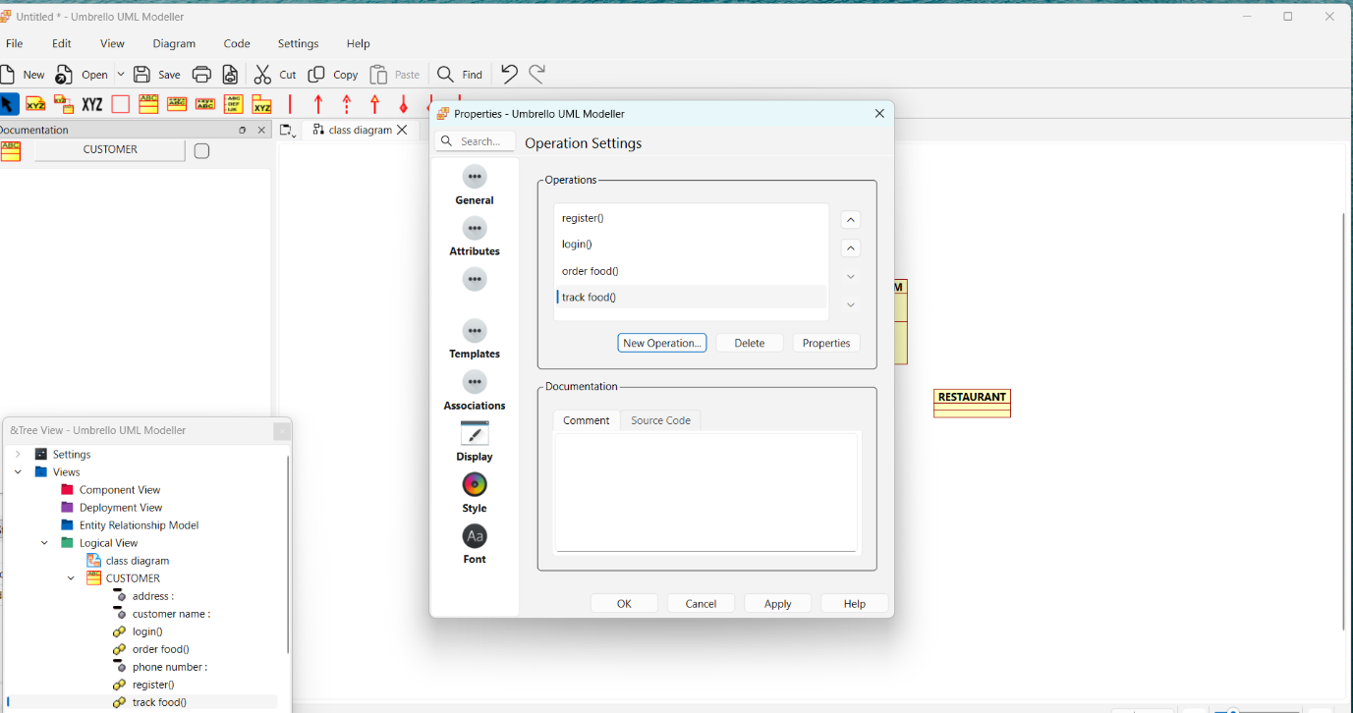
- Connect the classes using association relationships.
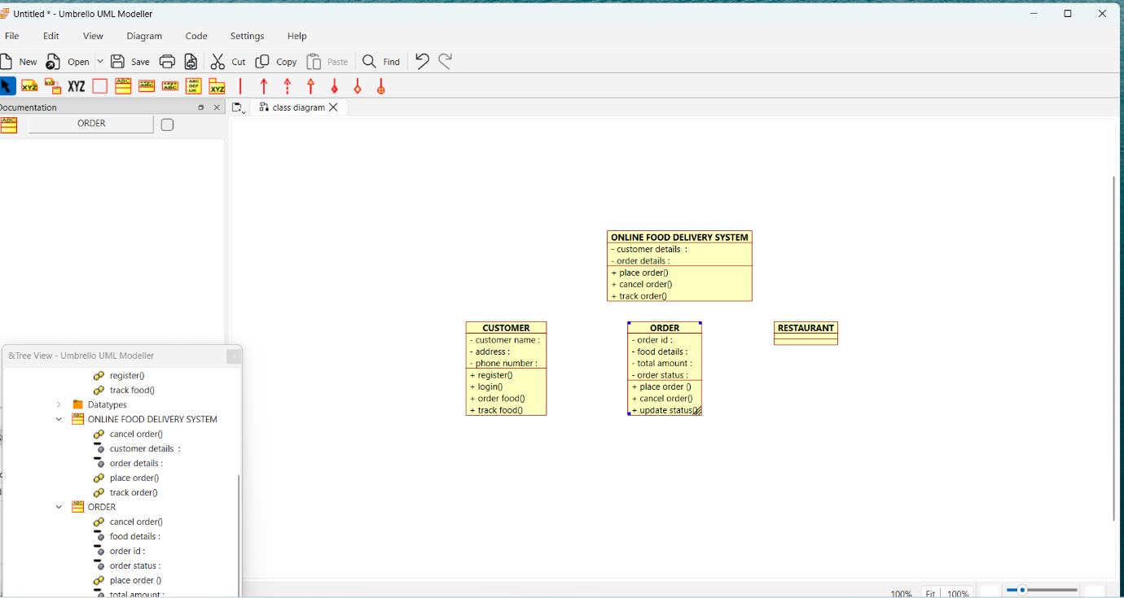
- Arrange the classes neatly.
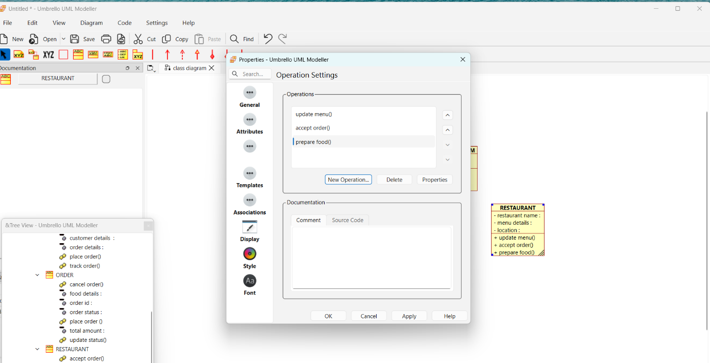
- Save the diagram.
- Verify that the diagram correctly represents the Online Food Delivery System.
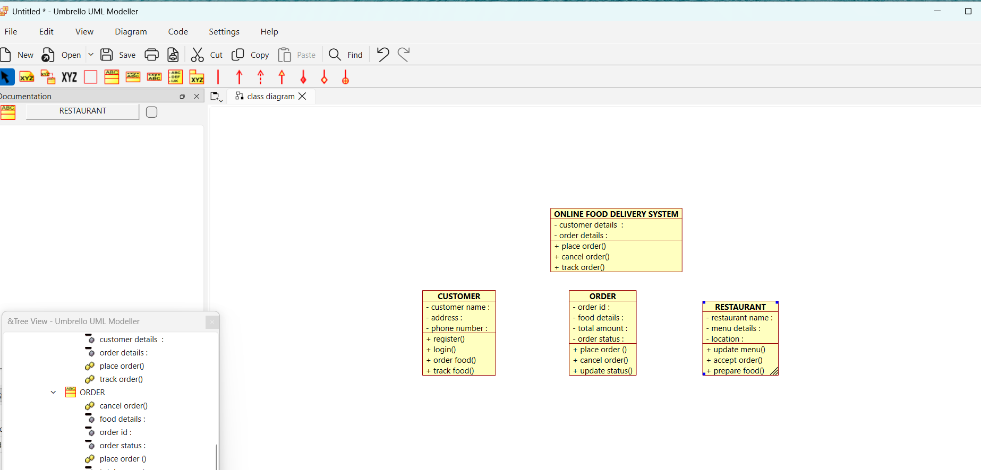
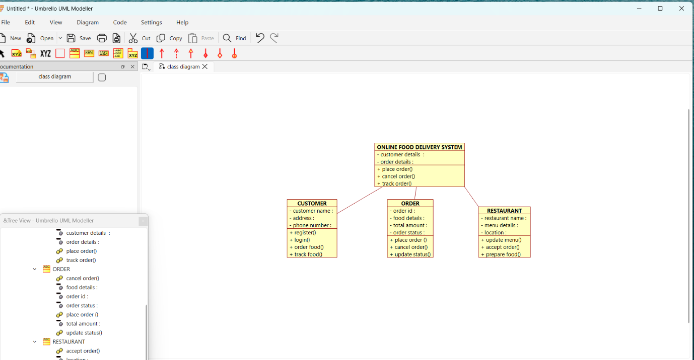
Use Case Diagram :

Procedure
- Open Umbrello UML Modeller.
- Create a new UML project.
- Select Use Case Diagram.
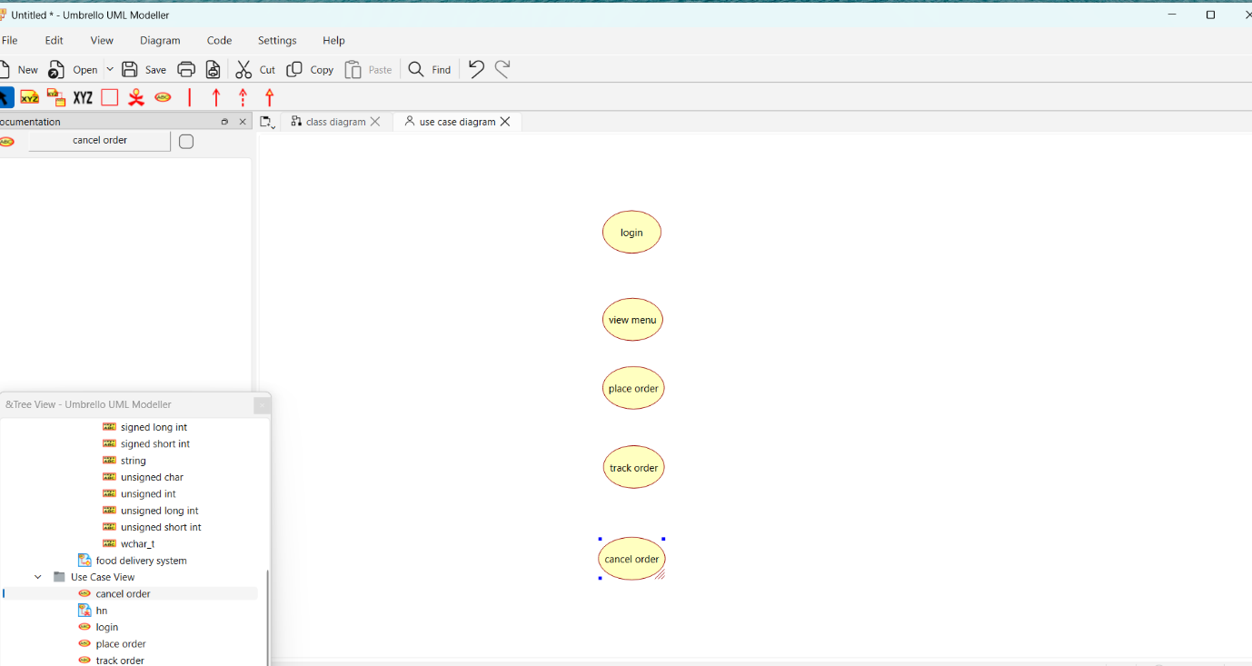
- Add the actors: Customer, Restaurant, and Delivery Agent.
- Create the use cases such as Register/Login, View Menu, Place Order, Make Payment, Track Order, Manage Menu, and Update Delivery Status.
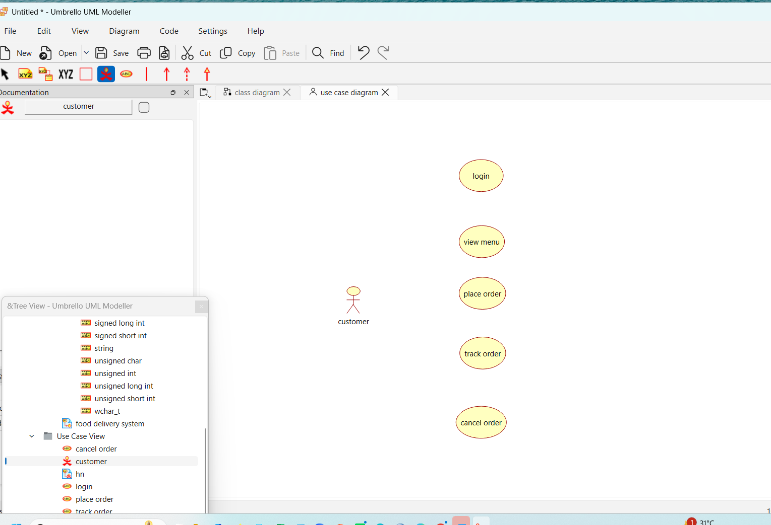
- Connect the actors to the appropriate use cases.
- Arrange the diagram neatly.
- Save the diagram.
- Verify that all user interactions are correctly represented.
